

DEDAN KIMATHI UNIVERSITY OF TECHNOLOGY FINAL PROJECT
DOCUMENTATION
SCHOOL OF COMPUTER SCIENCE AND IT
DEPARTMENT OF INFORMATION TECHNOLOGY
FINAL PROJECT DOCUMENTATION
BACHELOR OF SCIENCE INFORMATION TECHCNOLOGY
DEKAI

BY

MWANGI PRESTON WACHIRA
C027-01-0827/2022

SUPERVISED BY

DR. PARTRICK GIKUNDA

A project submitted to the department of information technology in the school of computer science and information technology in partial fulfillment of the requirements for the award of the degree of bsc.in business and information technology in Dedan Kimathi University of Technology.

DECLARATION
I Kirimi Nkatha Betty, Registration number C027-01-1404/2019 declare that this is my original work except for citations and quotations which have been duly acknowledged. I also declare that it has not been previously and concurrently submitted for any other degree or award at DEDAN KIMATHI UNIVERSITY

STUDENT CONFIRMATION
Name: MWANGI PRESTON WACHIRA Sign: ……………Date: …….
This research project document has been submitted with my approval as the university supervisor

SUPERVISOR CONFIRMATION
Name: MR PARTRICK GIKUNDA Sign: ……………Date: …….
Department of information technology

ACKNOWLEDGEMENT
I would first wish to acknowledge the Almighty God for a continued guidance through the whole process from idea generation to actual implementation of the project.
Secondly, I would like to acknowledge my supervisor, Mr Patrick Gikunda for his support.
Thirdly, I wish to extend my special thanks to the Registrar A&F’s office for facilitating my project implementation
Finally, I wish to acknowledge my family for their prayers encouragement and emotional support throughout the journey of system development.

ABSTRACT
Artificial Intelligence (AI) has increasingly become a vital tool in enhancing access to information, improving user interaction, and automating support services across various domains, including higher education. Universities generate vast amounts of information related to academics, administration, campus life, and events; however, this information is often fragmented across multiple platforms, making it difficult for students, staff, and visitors to access accurate and timely responses to their queries. At Dedan Kimathi University of Technology (DeKUT), this challenge is particularly evident among first-year students and prospective applicants who lack institutional familiarity.
This project presents DEKAI, an AI-powered virtual assistant designed to provide intelligent, real-time access to university-related information through natural language interaction and visual recognition. The system leverages Natural Language Processing (NLP) techniques to understand and respond to user queries in English, addressing frequently asked questions related to academic processes, campus services, and general university information. In addition, DEKAI incorporates a computer vision module trained using convolutional neural networks to recognize objects and major landmarks within and around the university campus, enhancing contextual understanding and usability.
A custom dataset consisting of campus-specific textual and image data is collected and used to fine-tune the NLP and image recognition models, ensuring domain relevance and accuracy. The trained models are integrated into a web-based chatbot interface to facilitate seamless real-time interaction. Performance evaluation is conducted by comparing the developed models against state-of-the-art approaches in both NLP and image recognition.
The DEKAI system aims to reduce information retrieval time, minimize misinformation, and improve communication efficiency within the university environment. By providing a centralized, intelligent, and user-friendly information access platform, the project demonstrates the practical application of AI technologies in improving institutional support services and enhancing the overall university experience.

CHAPTER 1
1.1 Introduction
1.2 Problem Statement
1.3 Objectives
1.3.1 General objectives
1.3.2 Specific objectives

CHAPTER 2
2.1 Literature review

CHAPTER 3
3.1 Proposed System architecture
3.2 Methodology
3.3 Timeline
3.4 Budget
3.5 Ethical Issues

CHAPTER 4
4.1 References

CHAPTER 1
  - Introduction
Artificial intelligence (AI) is the capability of computational systems to perform tasks typically associated with human intelligence, such as learning, reasoning, problem-solving, perception, and decision-making. It is a field of research in computer science that develops and studies methods and software that enable machines to perceive their environment and use learning and intelligence to take actions that maximize their chances of achieving defined goals. [5]
.Artificial Intelligence has different fields of study which include:
- Machine Learning- It is the scientific study of algorithms and statistical methods that computer systems use to effectively perform a task without using explicit instructions. [4]
- Computer Vision-Computer vision is an interdisciplinary field that deals with how computers can be made to gain high-level understanding from digital images or videos.[6]
- Robotics and predictive systems – Robotics , in the context of artificial intelligence (AI), refers to the design, construction, operation, and application of robots, especially those with AI capabilities [7]
Predictive systems are computer programs’ ability to use statistical analysis to identify patterns, anticipate behaviors, and forecast future events.[7]
Machine Learning itself encompasses a number of fields that use artificial neural networks such as Dense Neural Networks, Convolutional Neural networks, Recurrent Neural Networks and Transformer architectures to learn and generate patterns from input data.
The applications of Machine Learning are: 1. Image recognition
2. Speech recognition
3. Natural Language Processing (NLP)
4. Autonomous systems
Image recognition-Machine Learning algorithms can analyze and interpret images provided as training data and thus learn about classifying and recognizing new unseen data.
This enables for application in the fields of object identification and facial recognition.
During model training, Convolutional Neural Networks are used. CNNs are a special type of deep neural network that are particularly powerful for analyzing visual data. They can automatically detect relevant features from images and build a hierarchy of understanding — from low-level edges to high-level object parts.
Natural Language Processing (NLP)-It is a subfield of ML that is concerned with the interactions between computers and human (natural) language.[4] Modern deep learning techniques for NLP include word embedding (representing words, typically as vectors encoding their meaning) transformers (a deep learning architecture using an attention mechanism) and others.[5]
Artificial Intelligence is a rapidly growing field with advancements happening almost on a daily basis. Artificial Intelligence has come in a big way to help human beings in our day-to-day activities in different applications. One such application is chatbots and virtual assistants. One can say that having a well-trained chatbot is equal to having a library’s worth of information at your disposal.[8]
Artificial Intelligence has occupied the world and has so much to offer and even learn about to us as developers and the human population in general
Personally, I find that having the right information when doing anything goes a long way to actually helping you achieve the task in hand. This information may come in different formats such as understanding of an image, text or event. Nonetheless, we cannot dismiss how having factual information at any and all given time is of great value.
DEKAI brings this into perspective in the University domain, specifically Dedan Kimathi University, where any and all information about the university including past or present events is available from the A.I system.
1.2 Problem Statement
Students, staff, and prospective applicants at Dedan Kimathi University of Technology (Dekut) often face difficulties accessing accurate, timely, and structured information about campus services, academic processes, and general university information. Frequently Asked Questions (FAQs) such as course requirements, fee structures, event schedules, and departmental information are scattered across various sources including sometimes outdated websites and overloaded noticeboards. As a result, users spend unnecessary time searching or relying on word-of-mouth, which leads to misinformation, frustration, and inefficient communication. This information gap is especially critical for first-year students and visitors, who lack prior institutional familiarity.
Therefore, there is a pressing need for an AI-powered virtual assistant (DEKAI) capable of understanding natural language queries and providing instant, accurate answers related to campus life, academics, and administration. According to EDUCAUSE 2022, over 36% of institutions are deploying virtual assistants to reduce administrative workload.[3]

1.3 Objectives
1.3.1 General objectives
To develop an interactive NLP-based virtual assistant that responds to FAQs, provides general campus information and identifies major landmarks within and around Dedan Kimathi University.
1.3.2 Specific Objectives
1. To design and train a Natural Language Processing (NLP) model capable of understanding and generating responses to user queries in English.
2. To train an image recognition model to recognize random items.
3. To collect and create a custom dataset made up of images from and around the campus and fine-tune the image recognition model on the custom dataset to identify major landmarks on campus.
4. To integrate the model into a web-based chatbot interface for real-time user interaction.
5. To compare final trained Dekainlp and image recognition models to state-of-the-art models in their respective fields.

CHAPTER 2
2.1 Literature Review
Intelligent machines and computers have been developed to reduce time consumption and human efforts, improve safety, and increase quality of service. Having virtual assistants can play a critical role in using intelligent machines practically to complete tasks efficiently.[1]
Recent advancements in NLP, particularly the use of transformer-based models such as BERT (Bidirectional Encoder Representations from Transformers) [9] and GPT (Generative Pre-trained Transformer), have enabled machines to understand context and intent more accurately by using self-attention mechanisms to capture long-range dependencies and contextual meaning more effectively than previous RNN-based approaches. In 2017 the Transformer architecture was introduced which revolutionized NLP by allowing models to process words in relation to all other words in a sentence simultaneously. These models have proven effective in building intelligent, conversational systems with improved contextual awareness. [2]
The use of chatbots in higher education by admissions, student affairs, career services, and other student success and support units is not entirely new, but the Covid-19 pandemic has likely contributed to an increase in their use as they help students get efficient, relevant, and correct answers to their questions without long waits. [3]
In parallel, image recognition has emerged as a critical component of AI systems, especially in fields requiring visual data interpretation. Literature on image recognition highlights the dominance of Convolutional Neural Networks (CNNs), introduced by LeCun et al[10] which laid the foundation for most modern visual recognition tasks. Subsequent architectures such as AlexNet [11], VGGNet, and ResNet have significantly improved classification accuracy on benchmark datasets like ImageNet.
More recently, Vision Transformers (ViTs) have adapted the transformer architecture for image data. It was demonstrated that ViTs could outperform CNNs on large datasets, indicating a convergence of techniques between NLP and computer vision [12]. Furthermore, the application of image recognition in real-world educational settings is growing: studies such as Wang et al. (2021) have explored how visual AI can assist with digital campus systems—enabling features like automatic ID verification, form scanning, and even crowd monitoring.
Taken together, these bodies of literature provide a strong foundation for building intelligent systems that combine language and vision. The advancements in both NLP and image recognition enable the development of multimodal AI assistants capable of processing both textual and visual inputs—an approach increasingly relevant for next-generation smart services in education and beyond.
2.2 Case Studies

1. Georgia State University – “Pounce” Chatbot
Georgia State University deployed an AI chatbot called Pounce to assist students with:
- Admissions questions
- Financial aid
- Registration deadlines
- Orientation information
The chatbot primarily used Natural Language Processing (NLP) to answer FAQs via text messaging and web interfaces.

Impact
- Reduced summer enrollment “melt” by 21%
- Answered millions of student queries without human intervention
- Reduced administrative workload significantly

2. Arizona State University – “Sunny” Virtual Assistant
Arizona State University implemented Sunny, an AI-powered assistant integrated into student portals and mobile platforms. It provides:
- Course guidance
- Academic policies
- Campus navigation help
- Student services support
Sunny uses machine learning and conversational NLP to personalize responses.

Impact
- 24/7 student support
- Faster response times compared to human desks
- Improved student satisfaction scores
3. University of Nairobi – “Unibot”
An AI chatbot was developed to handle student inquiries. The chatbot uses Natural Language Processing (NLP) and Long Short-Term Memory (LSTM) models. It achieved a 0.75 BLEU score, indicating a high level of accuracy.

CHAPTER 3
3.1 Proposed system architecture

Frontend
Built using Streamlit, a lightweight Python web framework ideal for quick prototyping and interactive AI applications.
Allows users to:
1. Type questions in a text bar
2. Upload images for recognition
3. View model-generated responses in real time

Backend
Written in Python and integrates:
NLP(Transformer) model pipeline for handling text-based queries
Image recognition model pipeline for visual inputs
It is implemented using FastAPI to expose the model’s functionalities as RESTful APIs. These APIs handle:
- /generate – accepts user text queries and returns NLP-based responses.
- /vision_generate– processes uploaded images and returns classification results.

Machine Learning Models
Natural Language Processing Model that is trained unsupervised on: DailyDialog, WikiText, and AG News to generalize and understand context and fine-tuned on a custom FAQ dataset built from university questions.
Future extension - incorporate Kiswahili dataset to localize the model.

Image Recognition Model that is CNN-based, trained to recognize basic objects and university-specific landmarks (e.g., Freedom Hall, Resource Center) by fine-tuning it to a custom dataset of images from the university by applying data augmentation to enhance training diversity.

Database
The system is backed by a robust database that stores user credentials, conversation logs, prompts, and responses. This setup supports long-term model improvement through feedback loops and usage analysis, contributing to continuous performance optimization. Implemented with PostgreSQL
Table | Purpose
users | Store student accounts
conversations | Store all prompts and responses
feedback | Track useful responses, ratings, etc.
image logs | Log image queries (for analysis)

3.2 Methodology
3.2.1 Development Approach
DEKAI system will follow the Agile development model, which emphasizes iterative progress, continuous feedback, and modular development. This model allows the project to remain flexible and adaptive, especially when integrating and testing AI components such as NLP and image recognition. Weekly sprints and regular milestone reviews will be used to manage progress, with deliverables assessed at the end of each sprint.
3.2.2 Project Phases
1. Requirements Gathering
Identify key information needs from students and staff via informal interviews and document analysis (university website, FAQ sheets).
Define functional and non-functional requirements for the virtual assistant.
2. System Design
Design the architecture of the assistant including frontend (Streamlit), backend (FastAPI), NLP and vision modules, and PostgreSQL database.
Define API endpoints and data flows.
Plan database schema for storing interactions, image logs, and feedback.

3. Development
NLP model
Train transformer model (GPT-2 small or DistilGPT2), fine-tune on custom FAQ data.
Image recognition model
Train CNN using COCO + Dedan Kimathi landmark dataset.
Build frontend user interface for query input and image upload.
Develop backend API logic for routing queries to appropriate models.

4. Testing
NLP
Evaluate model responses to 50 curated FAQs (English + Kiswahili). Use accuracy, relevance, and human judgment.
Image model
Test using unseen images of campus landmarks, calculate precision, recall, and overall accuracy.
System testing
Perform end-to-end tests on real use cases; log bugs and improvements.

5. Deployment
Deploy the chatbot on a cloud server or local host for demonstration.
Log system usage for future iteration.

3.2.3 Data Collection and Evaluation
NLP Data:
General pretraining datasets: DailyDialog, AG News, WikiText.
Custom fine-tuning dataset: Web scraping data from university website.

Image Recognition Data:
COCO dataset for basic object recognition.
Custom dataset: Photographs of campus landmarks collected manually and labeled accordingly. Augmentation techniques such as flipping, rotation, and brightness adjustment will be applied to improve model generalization.

3.2.4 Progress Tracking
Progress will be tracked using milestones:

Proposal Approval
Model Training Completion
Frontend/Backend Integration
First Usability Test
Final System Deployment

A Gantt chart and task checklist will be maintained to monitor deadlines and deliverables.
3.2.5 Why AI is appropriate
The reason for using AI for this project is because DEKAI is designed to provide intelligent, natural, and context-aware responses to students and staff seeking campus-related information. Traditional rule-based systems or keyword search tools lack the flexibility to handle ambiguous, varied, or localized queries effectively.

3.2.6 Models to Be Used
Natural Language Processing Model
Type: Transformer-based language model (GPT-2 tiny or DistilGPT2)
Purpose: Understand and respond to campus-related FAQs in English (and later Kiswahili)
Frameworks: Hugging Face Transformers, TensorFlow

Image Classification Model
Type: Convolutional Neural Network
Purpose: Recognize common objects and campus-specific features (e.g., Freedom Hall, labs)
Frameworks: TensorFlow/Keras

3.2.7 Training and Testing
NLP Model
Pretraining: On general conversational datasets: DailyDialog, WikiText, AG News
Fine-tuning: On a custom dataset of Dekut FAQs (manually curated)
Evaluation: Human evaluation: accuracy of responses to 50 sample FAQs
User feedback logging for iterative improvement

Image Classification
Dataset: COCO (Common objects in context)
Custom dataset on Dedan Kimathi
Training: 80/20 training/testing split,
Metrics: Accuracy, precision, recall on test set
Testing: Upload unseen images to evaluate recognition of known locations

3.2.8 Ethical Use and Limitations
User Data Privacy - All user inputs and logs will be anonymized. No sensitive personal data is stored.
Bias & Fairness - The NLP model may reflect biases in training data. Local fine-tuning and Kiswahili inclusion help address this.
Misuse Prevention - The system is restricted to authenticated users (Dekut email), reducing risk of misuse or abuse.
Limitations:
1. The system may occasionally generate irrelevant or incorrect responses due to model limitations.
2. Image model is limited to trained categories (i.e., will not recognize arbitrary or unfamiliar items).
3. Multilingual support is limited initially, but Kiswahili is planned.

  - Timeline
Phase | Start Date | End Date | Duration | Description
Proposal document | June 4 | July 11 | 4 weeks | Finalize idea, write proposal, submit approval, panel presentation
System Design | July 14 | July 28 | 2 weeks | Design architecture, frontend, database and Backend components(NLP and Image recognition)
Dataset Preparation | July 28 | August 18 | 3 weeks | NLP Dataset  - DialyDialog, WikiText, AG News  -Custom FAQ creation  Image recognition Dataset  -COCO  -Custom Image dataset creation
Model Training and Fine tuning | August 18 | September 11 | 3.5 weeks | Train and test the LLM model and Image recognition models
Frontend (Chatbot User Interface) | September 11 | September 25 | 2 weeks | build web interface for DEKAI
Backend Development | September 25 | October 25 | 3.5 weeks | API, logic integration for NLP and image modules
Integration and testing | October 25 | November 3 | 3 weeks | Link frontend to backend, refine model response quality
Final Polishing & Deployment | November 3 | November 17 | 2 weeks | Hosting every component and final testing
Submission & Delivery | November 21 | November 25 | 1 week | Submit report, code, and system to supervisor

DEKAI PROJECT DEVELOPMENT GANTT CHART
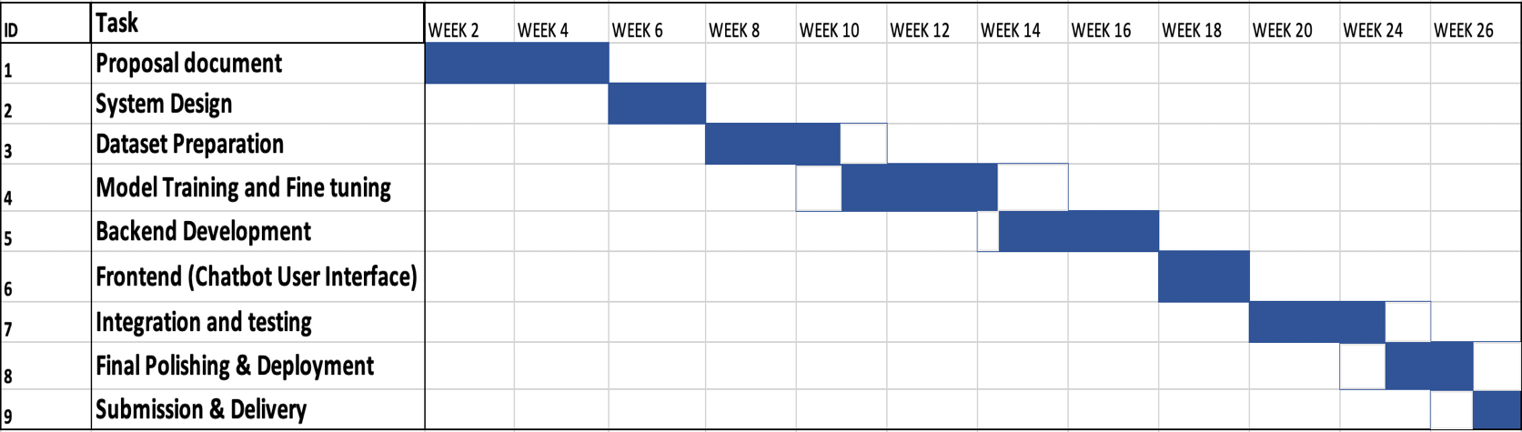

3.4 BUDGET
The budget of completing project DEKAI is as follows:
ITEMS | COST | Description
WIFI bill | 500/month | This is for the research and information gathering that I will do throughout the period
MacBook air M1 | 75,000 | This machine is what will assist me to train the models locally

3.5 Ethical Issues and considerations
1.Data privacy
Ethical issues of Anonymity, privacy and autonomy are interrelated. The potential misuse of data could lead to major privacy issues [13]. DEKAI collects data on user prompts to it and their respective responses and also stores user credentials for login.

Considerations
1.Use anonymized or synthetic data where possible such as during the custom FAQ dataset creation
2.Comply with data protection laws like Kenya’s Data Protection Act (2019)
3.Always get informed consent from users if you collect their data.

2. Bias and Fairness
AI models often reflect and amplify existing biases in training data, leading to unfair treatment.

Consideration:
1.Audit datasets and models for bias regularly.
2.Use diverse training data e.g. different dialects in the NLP training
3.Implement fairness metrics in evaluation.

3. Transparency

AI decisions (especially with deep learning) can be opaque or hard to explain. It is the work of developers to ensure their work is clear and can be replicable easily.

- Consideration:
1.Clearly document how DEKAI works and how it makes decisions.
2.Provide users with explanations when the system gives a response especially in sensitive scenarios.

Chapter 4: SYSTEM ANALYSIS AND DESIGN
4.1 Introduction
This chapter presents the system analysis and design of DEKAI, an AI-powered virtual assistant developed to provide intelligent access to academic, administrative, and campus-related information at Dedan Kimathi University of Technology. The chapter focuses on identifying system requirements, analyzing data needs, and presenting the architectural and logical design of the system. Various modeling tools such as data flow diagrams, use case diagrams, sequence diagrams, activity diagrams, and entity relationship diagrams are used to illustrate how the system operates and how different components interact.
4.2 Requirement Analysis
Requirement analysis defines the functional and non-functional needs of the DEKAI system to ensure it meets user expectations and institutional objectives.
4.2.1 Functional requirements
• Allow users to submit natural language queries in English.
• Interpret and process user queries using Natural Language Processing (NLP).
• Provide accurate responses to frequently asked questions related to:
- Admissions
- Academic processes
- Fees and finance
- Campus services
- Events and announcements
• Accept image input from users.
• Analyze images using a trained image recognition model.
• Identify objects and major landmarks within and around the university campus.
• Display responses in real time through a web-based chatbot interface.
• Maintain a structured knowledge base containing university-specific information.
• Log user queries for system improvement and evaluation.
• Allow administrators to update and maintain the knowledge base.

4.2.2 Non-Functional Requirements
The DEKAI system shall satisfy the following non-functional requirements:
- Performance
The system should respond to user queries within a reasonable time (less than 3 seconds for text queries).
- Usability
The user interface should be intuitive and easy to use for students, staff, and visitors.
- Scalability
The system should support an increasing number of users without degradation in performance.
- Reliability
The system should be available 24/7 with minimal downtime.
- Security
User data should be protected from unauthorized access.
- Maintainability
The system should be easy to update with new data and improved models

4.3 Data Analysis
The DEKAI system utilizes two main types of data:
- Textual Data
  - University documents
  - Academic calendars
  - Policy documents
  - Event announcements
- Image Data
  - Images of university landmarks
  - Buildings and facilities
  - Common objects within the campus environment
Text data is preprocessed using tokenization, normalization, and embedding techniques to support NLP model training. Image data is labeled and augmented to improve the robustness of the image recognition model. Both datasets are used to fine-tune pretrained deep learning models to ensure domain specificity and accuracy.

4.4 System Analysis

4.4.1 Data Flow Diagram (DFD)

DFD Level 0 (Context Diagram)

This shows DEKAI as a single system interacting with external entities.
- External Entity: User
- External Entity: Administrator
- Process: DEKAI System
- Data Stores: Knowledge Base, Image Dataset

Diagram (Structure)
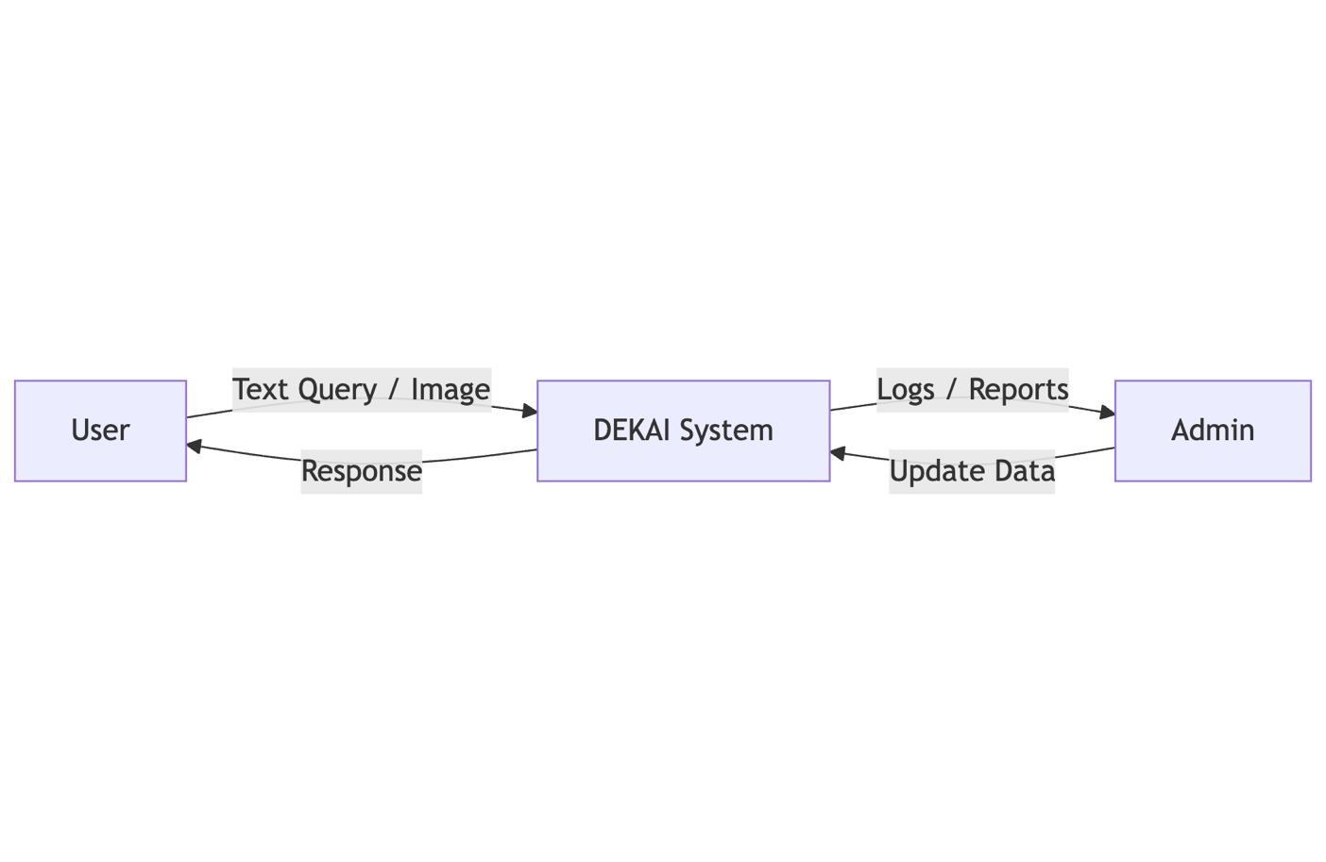

DFD Level 1
Breaks DEKAI into internal processes.

Processes
- Input Handler
- NLP Processing Module
- Image Recognition Module
- Knowledge Base Manager
- Response Generator

Data Stores
- Text Knowledge Base
- Image Dataset

Diagram
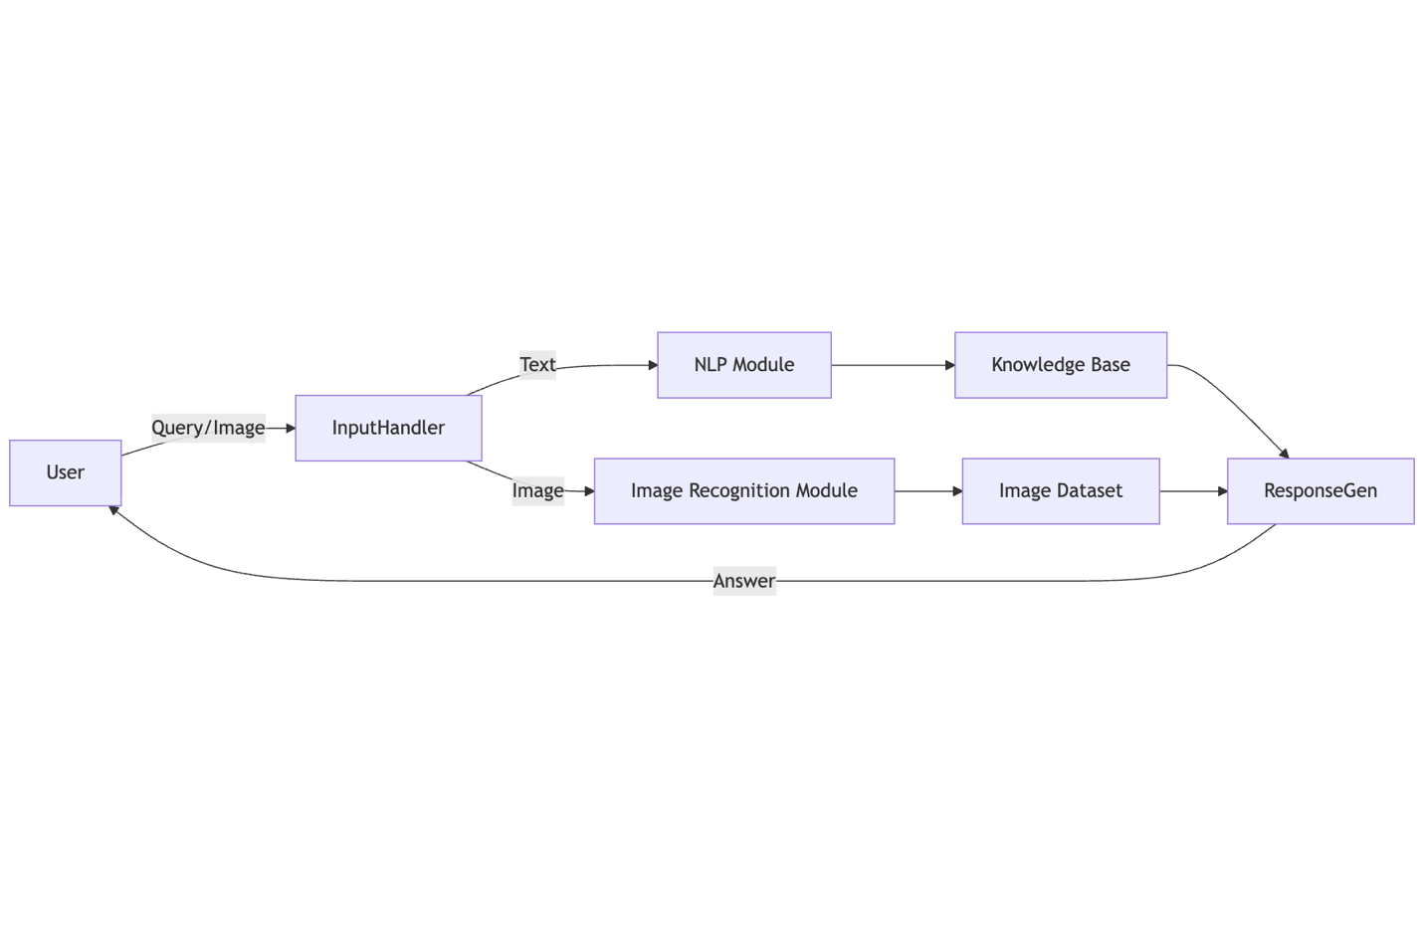

4.4.2 Use Case Diagram

Actors
- User (Student / Staff / Visitor)
- Administrator

Use Cases
- Ask Question
- Upload Image
- Receive Response
- Identify Landmark
- Update Knowledge Base
- Manage Dataset

Diagram
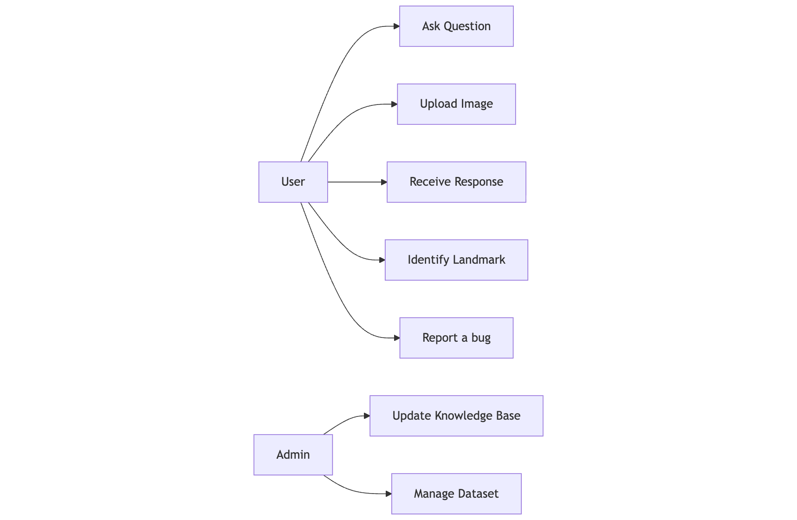

4.4.3 Sequence Diagram

Scenario: User asks a question

Flow
- User sends query
- System processes input
- NLP analyzes query
- Knowledge Base searched
- Response returned

Diagram
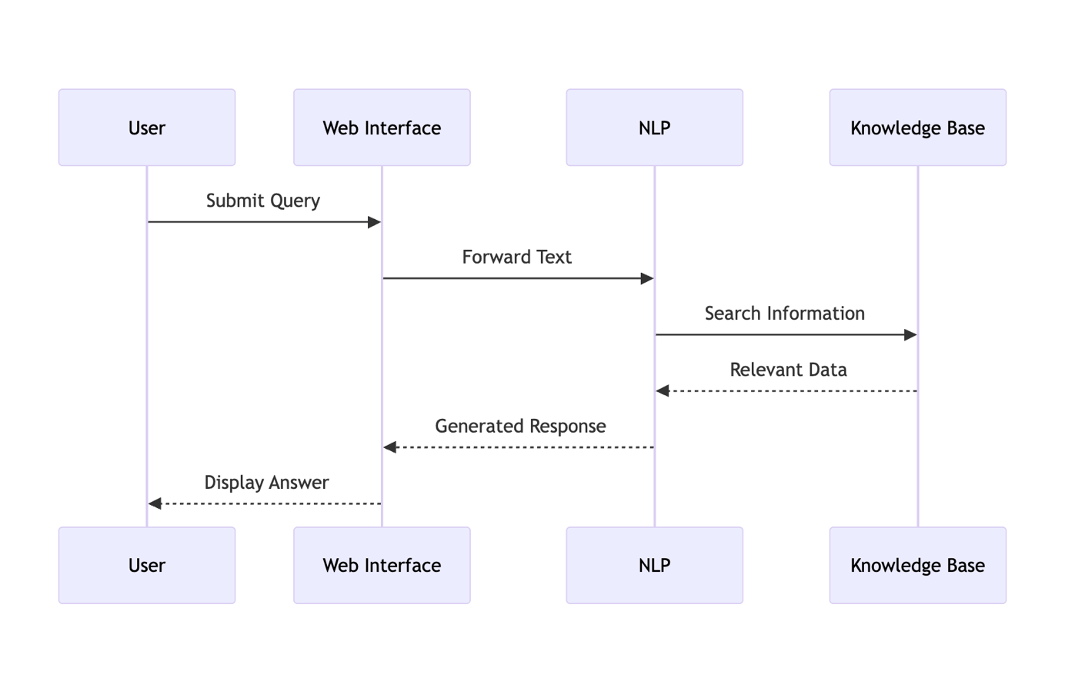
4.5 Activity Diagram

User Interaction Activity

Steps
- Start
- Enter query or upload image
- System processes input
- System generates response
- End

Diagram
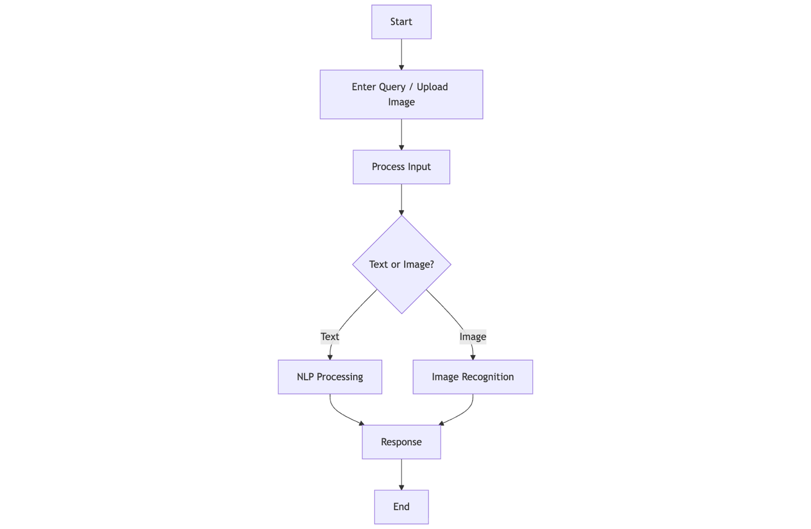

4.6 Entity Relationship Diagram (ERD)

Entities and Attributes

Entities
- User
- Query
- Response
- Image
- KnowledgeBase

Relationships
- User submits Query
- Query produces Response
- Query may include Image
- Response references KnowledgeBase

Diagram
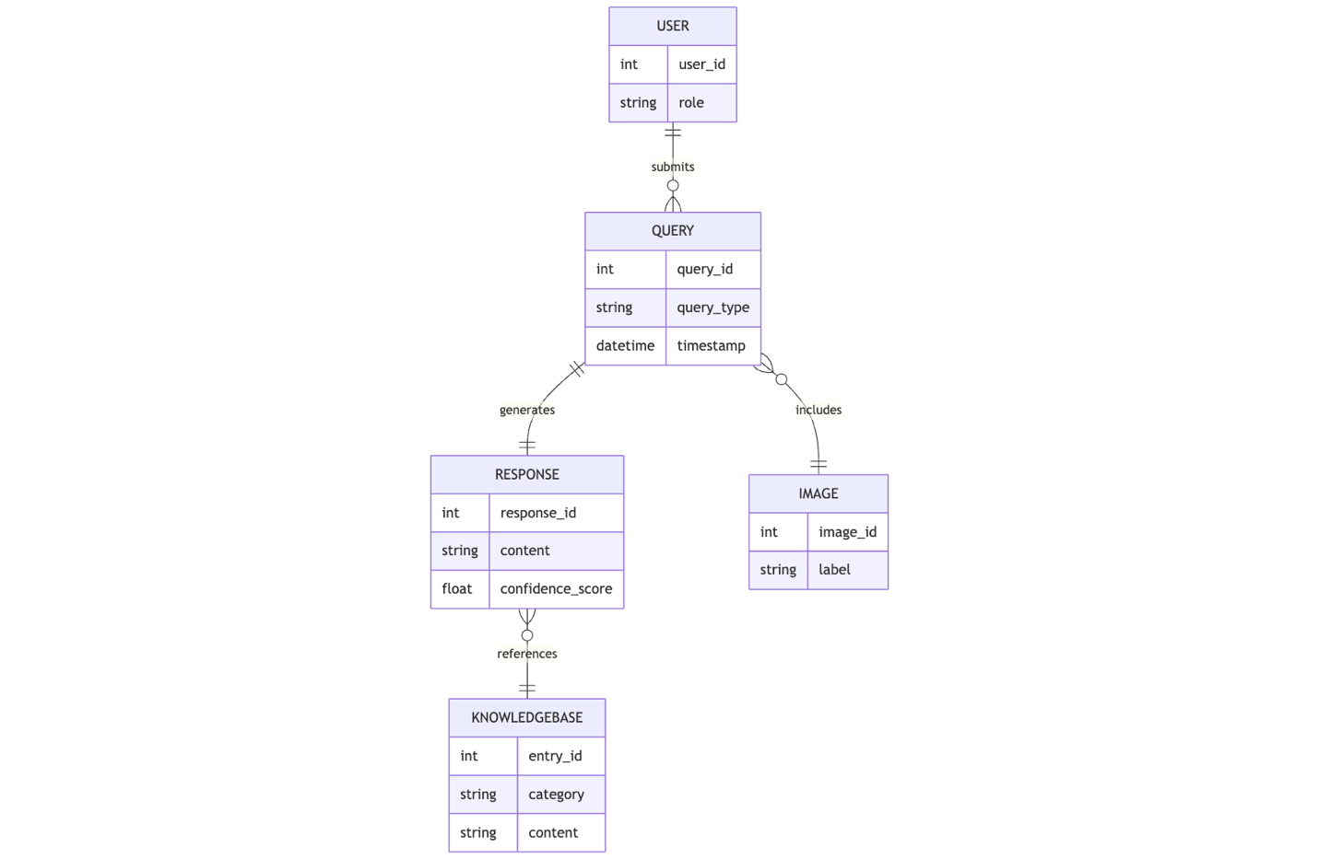

CHAPTER 5
5.1 NLP Implementation
5.1.1 Dekainlp1
This research and Testing is based on developing an Nlp model from scratch without use of pretrained models.

19th September 2025
Created tensor flow based transformer for the DEKAI NLP component
Training on Dailydialog dataset and using Kaggle platform for 15 epochs
Training
Epoch 1/15

13/2377 ━━━━━━━━━━━━━━━━━━━━ 32s 14ms/step - accuracy: 0.4840 - loss: 8.1143
I0000 00:00:1758278250.571707 103 device_compiler.h:188] Compiled cluster using XLA! This line is logged at most once for the lifetime of the process.
2375/2377 ━━━━━━━━━━━━━━━━━━━━ 0s 13ms/step - accuracy: 0.7273 - loss: 1.9655
W0000 00:00:1758278281.901140 100 assert_op.cc:38] Ignoring Assert operator compile_loss/sparse_categorical_crossentropy/SparseSoftmaxCrossEntropyWithLogits/assert_equal_1/Assert/Assert
2377/2377 ━━━━━━━━━━━━━━━━━━━━ 0s 16ms/step - accuracy: 0.7273 - loss: 1.9652
W0000 00:00:1758278289.789810 103 assert_op.cc:38] Ignoring Assert operator compile_loss/sparse_categorical_crossentropy/SparseSoftmaxCrossEntropyWithLogits/assert_equal_1/Assert/Assert
W0000 00:00:1758278292.068060 101 assert_op.cc:38] Ignoring Assert operator compile_loss/sparse_categorical_crossentropy/SparseSoftmaxCrossEntropyWithLogits/assert_equal_1/Assert/Assert
2377/2377 ━━━━━━━━━━━━━━━━━━━━ 69s 18ms/step - accuracy: 0.7273 - loss: 1.9650 - val_accuracy: 0.7567 - val_loss: 1.3742
Epoch 2/15
2377/2377 ━━━━━━━━━━━━━━━━━━━━ 32s 14ms/step - accuracy: 0.7513 - loss: 1.3931 - val_accuracy: 0.7629 - val_loss: 1.3081
Epoch 3/15
2377/2377 ━━━━━━━━━━━━━━━━━━━━ 32s 14ms/step - accuracy: 0.7587 - loss: 1.2797 - val_accuracy: 0.7653 - val_loss: 1.2827
Epoch 4/15
2377/2377 ━━━━━━━━━━━━━━━━━━━━ 33s 14ms/step - accuracy: 0.7661 - loss: 1.1965 - val_accuracy: 0.7676 - val_loss: 1.2743
Epoch 5/15
2377/2377 ━━━━━━━━━━━━━━━━━━━━ 32s 13ms/step - accuracy: 0.7727 - loss: 1.1328 - val_accuracy: 0.7685 - val_loss: 1.2739
Epoch 6/15
2377/2377 ━━━━━━━━━━━━━━━━━━━━ 32s 13ms/step - accuracy: 0.7789 - loss: 1.0826 - val_accuracy: 0.7695 - val_loss: 1.2815
Epoch 7/15
2377/2377 ━━━━━━━━━━━━━━━━━━━━ 32s 14ms/step - accuracy: 0.7845 - loss: 1.0393 - val_accuracy: 0.7700 - val_loss: 1.2899
Epoch 8/15
2377/2377 ━━━━━━━━━━━━━━━━━━━━ 32s 13ms/step - accuracy: 0.7898 - loss: 1.0036 - val_accuracy: 0.7701 - val_loss: 1.2991
Epoch 9/15
2377/2377 ━━━━━━━━━━━━━━━━━━━━ 32s 14ms/step - accuracy: 0.7942 - loss: 0.9725 - val_accuracy: 0.7699 - val_loss: 1.3132
Epoch 10/15
2377/2377 ━━━━━━━━━━━━━━━━━━━━ 32s 13ms/step - accuracy: 0.7985 - loss: 0.9454 - val_accuracy: 0.7714 - val_loss: 1.3233
Epoch 11/15
2377/2377 ━━━━━━━━━━━━━━━━━━━━ 33s 14ms/step - accuracy: 0.8022 - loss: 0.9201 - val_accuracy: 0.7713 - val_loss: 1.3404
Epoch 12/15
2377/2377 ━━━━━━━━━━━━━━━━━━━━ 32s 14ms/step - accuracy: 0.8057 - loss: 0.8990 - val_accuracy: 0.7715 - val_loss: 1.3484
Epoch 13/15
2377/2377 ━━━━━━━━━━━━━━━━━━━━ 32s 14ms/step - accuracy: 0.8087 - loss: 0.8798 - val_accuracy: 0.7712 - val_loss: 1.3585
Epoch 14/15
2377/2377 ━━━━━━━━━━━━━━━━━━━━ 32s 13ms/step - accuracy: 0.8112 - loss: 0.8627 - val_accuracy: 0.7715 - val_loss: 1.3814
Epoch 15/15
2377/2377 ━━━━━━━━━━━━━━━━━━━━ 32s 13ms/step - accuracy: 0.8139 - loss: 0.8461 - val_accuracy: 0.7714 - val_loss: 1.3956

Saved model to DEKAINLP1.1.keras

Validation Code snippet
val_loss, val_acc = loaded_model.evaluate(val_ds)
print(f"Validation Loss: {val_loss:.4f}, Validation Accuracy: {val_acc:.4f}")
test_loss, test_acc = loaded_model.evaluate(test_ds)
print(f"Test Loss: {test_loss:.4f}, Test Accuracy: {test_acc:.4f}")

Validation Output
W0000 00:00:1758531206.920791 97 assert_op.cc:38] Ignoring Assert operator compile_loss/sparse_categorical_crossentropy/SparseSoftmaxCrossEntropyWithLogits/assert_equal_1/Assert/Assert
221/221 ━━━━━━━━━━━━━━━━━━━━ 7s 11ms/step - accuracy: 0.7683 - loss: 1.4327
Validation Loss: 1.3921, Validation Accuracy: 0.7725
199/211 ━━━━━━━━━━━━━━━━━━━━ 0s 5ms/step - accuracy: 0.7706 - loss: 1.4037
W0000 00:00:1758531209.523181 96 assert_op.cc:38] Ignoring Assert operator compile_loss/sparse_categorical_crossentropy/SparseSoftmaxCrossEntropyWithLogits/assert_equal_1/Assert/Assert
211/211 ━━━━━━━━━━━━━━━━━━━━ 3s 11ms/step - accuracy: 0.7702 - loss: 1.4062
Test Loss: 1.4448, Test Accuracy: 0.7637

Inference snippet
test_sentence = "hello"
print("User:", test_sentence)
print("DEKAI 1.1 :", generate_reply(loaded_model, vectorizer, test_sentence))
Inference output
User: hello
DEKAI: hi is there in the northwest airlines calling is im calling

Comments
1.77% on val accuracy is quite okay ….
2.The model does well on the testing dataset too with a 76% accuracy
3.The output is abit gibberish but it’s a starting point

Things to add or change in the next training session
1.Change from using greedy algorithm in the inferences and change to beam search
2.Use better performance testing metrics eg BLEU, CIDEr, or ROUGE scores

*Changed from Greedy search algorithm to Beam search
Inference snippet
test_sentence = "whats up? "
print("User:", test_sentence)
print("DEKAI:", generate_reply_beam(loaded_model, vectorizer, test_sentence))

Model Output
User: whats up?
DEKAI 1.1 : i dont know

Comments
This shows improved generation when using beam search algorithm

1st October 2025
Training the same model architecture on a combined dataset of wikitext , persona chat and Dailydialog

Training
Epoch 1/20
WARNING: All log messages before absl::InitializeLog() is called are written to STDERR
I0000 00:00:1759487023.925254 131 service.cc:148] XLA service 0x7b669c00e720 initialized for platform CUDA (this does not guarantee that XLA will be used). Devices:
I0000 00:00:1759487023.926215 131 service.cc:156] StreamExecutor device (0): Tesla P100-PCIE-16GB, Compute Capability 6.0
W0000 00:00:1759487024.893534 131 assert_op.cc:38] Ignoring Assert operator compile_loss/sparse_categorical_crossentropy/SparseSoftmaxCrossEntropyWithLogits/assert_equal_1/Assert/Assert
I0000 00:00:1759487025.718304 131 cuda_dnn.cc:529] Loaded cuDNN version 90300
9/12731 ━━━━━━━━━━━━━━━━━━━━ 3:12 15ms/step - accuracy: 0.1903 - loss: 9.5597
I0000 00:00:1759487031.259903 131 device_compiler.h:188] Compiled cluster using XLA! This line is logged at most once for the lifetime of the process.
12728/12731 ━━━━━━━━━━━━━━━━━━━━ 0s 14ms/step - accuracy: 0.8742 - loss: 1.0015
W0000 00:00:1759487205.117843 131 assert_op.cc:38] Ignoring Assert operator compile_loss/sparse_categorical_crossentropy/SparseSoftmaxCrossEntropyWithLogits/assert_equal_1/Assert/Assert
12731/12731 ━━━━━━━━━━━━━━━━━━━━ 0s 14ms/step - accuracy: 0.8743 - loss: 1.0013
W0000 00:00:1759487212.430366 129 assert_op.cc:38] Ignoring Assert operator compile_loss/sparse_categorical_crossentropy/SparseSoftmaxCrossEntropyWithLogits/assert_equal_1/Assert/Assert
W0000 00:00:1759487220.785158 131 assert_op.cc:38] Ignoring Assert operator compile_loss/sparse_categorical_crossentropy/SparseSoftmaxCrossEntropyWithLogits/assert_equal_1/Assert/Assert
12731/12731 ━━━━━━━━━━━━━━━━━━━━ 217s 15ms/step - accuracy: 0.8743 - loss: 1.0012 - val_accuracy: 0.9979 - val_loss: 0.0206
Epoch 2/20
12731/12731 ━━━━━━━━━━━━━━━━━━━━ 181s 14ms/step - accuracy: 0.9979 - loss: 0.0193 - val_accuracy: 0.9982 - val_loss: 0.0165
Epoch 3/20
12731/12731 ━━━━━━━━━━━━━━━━━━━━ 181s 14ms/step - accuracy: 0.9983 - loss: 0.0158 - val_accuracy: 0.9983 - val_loss: 0.0158
Epoch 4/20
12731/12731 ━━━━━━━━━━━━━━━━━━━━ 181s 14ms/step - accuracy: 0.9985 - loss: 0.0143 - val_accuracy: 0.9983 - val_loss: 0.0172
Epoch 5/20
12731/12731 ━━━━━━━━━━━━━━━━━━━━ 181s 14ms/step - accuracy: 0.9986 - loss: 0.0138 - val_accuracy: 0.9984 - val_loss: 0.0155
Epoch 6/20
12731/12731 ━━━━━━━━━━━━━━━━━━━━ 181s 14ms/step - accuracy: 0.9987 - loss: 0.0138 - val_accuracy: 0.9985 - val_loss: 0.0157
Epoch 7/20
12731/12731 ━━━━━━━━━━━━━━━━━━━━ 183s 14ms/step - accuracy: 0.9987 - loss: 0.0135 - val_accuracy: 0.9986 - val_loss: 0.0151
Epoch 8/20
12731/12731 ━━━━━━━━━━━━━━━━━━━━ 182s 14ms/step - accuracy: 0.9987 - loss: 0.0141 - val_accuracy: 0.9984 - val_loss: 0.0168
Epoch 9/20
12731/12731 ━━━━━━━━━━━━━━━━━━━━ 183s 14ms/step - accuracy: 0.9987 - loss: 0.0139 - val_accuracy: 0.9987 - val_loss: 0.0141
Epoch 10/20
12731/12731 ━━━━━━━━━━━━━━━━━━━━ 182s 14ms/step - accuracy: 0.9987 - loss: 0.0141 - val_accuracy: 0.9982 - val_loss: 0.0191
Epoch 11/20
12731/12731 ━━━━━━━━━━━━━━━━━━━━ 183s 14ms/step - accuracy: 0.9986 - loss: 0.0148 - val_accuracy: 0.9988 - val_loss: 0.0140
Epoch 12/20
12731/12731 ━━━━━━━━━━━━━━━━━━━━ 190s 15ms/step - accuracy: 0.9987 - loss: 0.0140 - val_accuracy: 0.9982 - val_loss: 0.0197
Epoch 13/20
12731/12731 ━━━━━━━━━━━━━━━━━━━━ 191s 15ms/step - accuracy: 0.9986 - loss: 0.0149 - val_accuracy: 0.9984 - val_loss: 0.0180
Epoch 14/20
12731/12731 ━━━━━━━━━━━━━━━━━━━━ 190s 15ms/step - accuracy: 0.9986 - loss: 0.0152 - val_accuracy: 0.9983 - val_loss: 0.0186
Epoch 15/20
12731/12731 ━━━━━━━━━━━━━━━━━━━━ 190s 15ms/step - accuracy: 0.9986 - loss: 0.0149 - val_accuracy: 0.9980 - val_loss: 0.0217
Epoch 16/20
12731/12731 ━━━━━━━━━━━━━━━━━━━━ 190s 15ms/step - accuracy: 0.9986 - loss: 0.0145 - val_accuracy: 0.9985 - val_loss: 0.0169
Epoch 17/20
12731/12731 ━━━━━━━━━━━━━━━━━━━━ 190s 15ms/step - accuracy: 0.9986 - loss: 0.0148 - val_accuracy: 0.9981 - val_loss: 0.0202
Epoch 18/20
12731/12731 ━━━━━━━━━━━━━━━━━━━━ 191s 15ms/step - accuracy: 0.9985 - loss: 0.0154 - val_accuracy: 0.9981 - val_loss: 0.0205
Epoch 19/20
12731/12731 ━━━━━━━━━━━━━━━━━━━━ 199s 16ms/step - accuracy: 0.9986 - loss: 0.0155 - val_accuracy: 0.9984 - val_loss: 0.0178
Epoch 20/20
12731/12731 ━━━━━━━━━━━━━━━━━━━━ 201s 16ms/step - accuracy: 0.9986 - loss: 0.0152 - val_accuracy: 0.9977 - val_loss: 0.0255
Saved model to DEKAINLP1.2.keras

Inferences snippet
test_sentence = "whats up? "
print("User:", test_sentence)
print("DEKAI 1.2 :", generate_reply_beam(loaded_model, vectorizer, test_sentence))

Output
User: Hello how are you ?
DEKAI 1.2:

Comments
1. The accuracy scored scared me a little bit for reaching 99% accuracy …This is the first model I have trained that has gotten to that threshold
2.It does not produce any output . My hypothesis is because of the combined dataset, wikitext drowns out the special tokens <start> and <end> hence generation is impaired ….
3.I’d also like to keep the model as more of a pretrained one then try and finetune it with purely conversational datasets such as daily dialog

Next Update
-Change from Encoder and decoder to decoder only transformer
-In the tokenizer, set special tokens <start> <end> <mask> manually before adapting the whole tokenizer to ensure they have stable and consistent known IDs
-Pretrain an encoder only transformer on Wikitext alone to ensure good next token prediction and generation and good language modelling then finetune it on conversational datasets such as persona chat.(DEKAI 1.3)

6th October 2025
DEKAINLP 0
This uses pretrained models to act as a base for Dekai’s nlp model which I would finetune later on the custom dataset.
Model used: microsoft/DialoGPT-medium
Code
from transformers import AutoModelForCausalLM, AutoTokenizer
import torch

model_name = "microsoft/DialoGPT-medium"
tokenizer = AutoTokenizer.from_pretrained(model_name)
model = AutoModelForCausalLM.from_pretrained(model_name)

chat_history_ids = None

def chat(user_input):
global chat_history_ids
new_input_ids = tokenizer.encode(user_input + tokenizer.eos_token, return_tensors='pt')

bot_input_ids = torch.cat([chat_history_ids, new_input_ids], dim=-1) if chat_history_ids is not None else new_input_ids

chat_history_ids = model.generate(
bot_input_ids,
max_length=1000,
pad_token_id=tokenizer.eos_token_id
)

reply = tokenizer.decode(chat_history_ids[:, bot_input_ids.shape[-1]:][0], skip_special_tokens=True)
return reply

Inference Snippet
print(chat("Hey, how are you?"))
print(chat("I'm good "))
print(chat("What is the weather like?"))
print(chat("What do you like ?"))

Model Output
I'm good.
Good, good.
It's nice.
I like the weather.

Comments
1.The model does poorly if history is not involved. But with addition of the history and conversation aspect the model shows proper token generation and context awareness.
2.This model might prove very useful in the creation of DEKAI 0

DEKAINLP1.3
Training logs
Epoch 1/15
/usr/local/lib/python3.11/dist-packages/keras/src/backend/tensorflow/nn.py:708: UserWarning: "`sparse_categorical_crossentropy` received `from_logits=True`, but the `output` argument was produced by a Softmax activation and thus does not represent logits. Was this intended?
output, from_logits = _get_logits(
WARNING: All log messages before absl::InitializeLog() is called are written to STDERR
I0000 00:00:1759753032.502332 119 service.cc:148] XLA service 0x7b14b4000d90 initialized for platform CUDA (this does not guarantee that XLA will be used). Devices:
I0000 00:00:1759753032.502935 119 service.cc:156] StreamExecutor device (0): Tesla T4, Compute Capability 7.5
I0000 00:00:1759753032.502957 119 service.cc:156] StreamExecutor device (1): Tesla T4, Compute Capability 7.5
W0000 00:00:1759753033.605248 119 assert_op.cc:38] Ignoring Assert operator compile_loss/sparse_categorical_crossentropy/SparseSoftmaxCrossEntropyWithLogits/assert_equal_1/Assert/Assert
I0000 00:00:1759753034.496517 119 cuda_dnn.cc:529] Loaded cuDNN version 90300
2/18204 ━━━━━━━━━━━━━━━━━━━━ 19:24 64ms/step - accuracy: 1.9531e-04 - loss: 10.5801
I0000 00:00:1759753043.423138 119 device_compiler.h:188] Compiled cluster using XLA! This line is logged at most once for the lifetime of the process.
18203/18204 ━━━━━━━━━━━━━━━━━━━━ 0s 47ms/step - accuracy: 0.5903 - loss: 3.4994
W0000 00:00:1759753904.938887 119 assert_op.cc:38] Ignoring Assert operator compile_loss/sparse_categorical_crossentropy/SparseSoftmaxCrossEntropyWithLogits/assert_equal_1/Assert/Assert
18204/18204 ━━━━━━━━━━━━━━━━━━━━ 0s 48ms/step - accuracy: 0.5903 - loss: 3.4993
W0000 00:00:1759753914.906748 119 assert_op.cc:38] Ignoring Assert operator compile_loss/sparse_categorical_crossentropy/SparseSoftmaxCrossEntropyWithLogits/assert_equal_1/Assert/Assert
W0000 00:00:1759753916.894249 119 assert_op.cc:38] Ignoring Assert operator compile_loss/sparse_categorical_crossentropy/SparseSoftmaxCrossEntropyWithLogits/assert_equal_1/Assert/Assert
18204/18204 ━━━━━━━━━━━━━━━━━━━━ 908s 48ms/step - accuracy: 0.5903 - loss: 3.4993 - val_accuracy: 0.8701 - val_loss: 1.0247
Epoch 2/15
18204/18204 ━━━━━━━━━━━━━━━━━━━━ 867s 48ms/step - accuracy: 0.8739 - loss: 0.9722 - val_accuracy: 0.9082 - val_loss: 0.7086
Epoch 3/15
18204/18204 ━━━━━━━━━━━━━━━━━━━━ 864s 47ms/step - accuracy: 0.9065 - loss: 0.7147 - val_accuracy: 0.9113 - val_loss: 0.6619
Epoch 4/15
18204/18204 ━━━━━━━━━━━━━━━━━━━━ 866s 48ms/step - accuracy: 0.9126 - loss: 0.6550 - val_accuracy: 0.9133 - val_loss: 0.6373
Epoch 5/15
18204/18204 ━━━━━━━━━━━━━━━━━━━━ 866s 48ms/step - accuracy: 0.9142 - loss: 0.6337 - val_accuracy: 0.9129 - val_loss: 0.6337
Epoch 6/15
18204/18204 ━━━━━━━━━━━━━━━━━━━━ 867s 48ms/step - accuracy: 0.9149 - loss: 0.6233 - val_accuracy: 0.9146 - val_loss: 0.6188
Epoch 7/15
18204/18204 ━━━━━━━━━━━━━━━━━━━━ 866s 48ms/step - accuracy: 0.9155 - loss: 0.6132 - val_accuracy: 0.9142 - val_loss: 0.6136
Epoch 8/15
18204/18204 ━━━━━━━━━━━━━━━━━━━━ 867s 48ms/step - accuracy: 0.9159 - loss: 0.6063 - val_accuracy: 0.9143 - val_loss: 0.6087
Epoch 9/15
18204/18204 ━━━━━━━━━━━━━━━━━━━━ 865s 47ms/step - accuracy: 0.9163 - loss: 0.6000 - val_accuracy: 0.9142 - val_loss: 0.6080
Epoch 10/15
18204/18204 ━━━━━━━━━━━━━━━━━━━━ 870s 48ms/step - accuracy: 0.9165 - loss: 0.5960 - val_accuracy: 0.9153 - val_loss: 0.6045
Epoch 11/15
18204/18204 ━━━━━━━━━━━━━━━━━━━━ 873s 48ms/step - accuracy: 0.9167 - loss: 0.5913 - val_accuracy: 0.9151 - val_loss: 0.5975
Epoch 12/15
18204/18204 ━━━━━━━━━━━━━━━━━━━━ 878s 48ms/step - accuracy: 0.9170 - loss: 0.5877 - val_accuracy: 0.9147 - val_loss: 0.5947
Epoch 13/15
18204/18204 ━━━━━━━━━━━━━━━━━━━━ 881s 48ms/step - accuracy: 0.9172 - loss: 0.5851 - val_accuracy: 0.9162 - val_loss: 0.5909
Epoch 14/15
18204/18204 ━━━━━━━━━━━━━━━━━━━━ 881s 48ms/step - accuracy: 0.9172 - loss: 0.5826 - val_accuracy: 0.9166 - val_loss: 0.5874
Epoch 15/15
18204/18204 ━━━━━━━━━━━━━━━━━━━━ 879s 48ms/step - accuracy:
0.9175 - loss: 0.5796 - val_accuracy: 0.9154 - val_loss: 0.5919
Saved model to DEKAINLP1.3.keras

7th October 2025
Inference snippet
prompt = "The earth is "
output = generate_text(prompt)
print(f"User: {prompt}")
print(f"DEKAI: {output}")

Output
User: The earth is
DEKAI: bowlers gainer instrumental 70 ortved penzance pradesh lila genji overhanging inflected journals arafat land livonia deserted edessa scurvy drawings mira specifications ph approved midwest deshastha hla jna rooney occurrences guts litres lyman cultivation lausanne spills tabled 120a skull kristallnacht refuge
Comments
1. The model has an accuracy of “val_accuracy: 0.9154” which I think the model might have overfitted on the data
2.The model can complete text well (linguistically fluent), but it doesn’t know how to stay on topic because it wasn’t trained on turn-by-turn dialogue. Fine-tuning on Dailydialog dataset will possibly fix this.
3.
Next Update
-Use Top-p sampling algorithm to improve generation.
-Finetune the model on dailydialog that is preprocessed the same way as training data for DEKAINLP1.1
DEKAINLP1.4
14th October 2025
This is model 1.3 that was trained on WIKITEXT dataset that has now been finetuned on the Dailydialog dataset.
-Used top-p sampling algorithm for the inference
-Used learning rate of 5e-5
Finetuning logs
Epoch 1/3
WARNING: All log messages before absl::InitializeLog() is called are written to STDERR
I0000 00:00:1760085862.427286 58 service.cc:148] XLA service 0x7a1d0c003550 initialized for platform CUDA (this does not guarantee that XLA will be used). Devices:
I0000 00:00:1760085862.428119 58 service.cc:156] StreamExecutor device (0): Tesla P100-PCIE-16GB, Compute Capability 6.0
W0000 00:00:1760085863.677689 58 assert_op.cc:38] Ignoring Assert operator compile_loss/sparse_categorical_crossentropy/SparseSoftmaxCrossEntropyWithLogits/assert_equal_1/Assert/Assert
I0000 00:00:1760085864.633835 58 cuda_dnn.cc:529] Loaded cuDNN version 90300
5/Unknown 52s 30ms/step - accuracy: 0.7730 - loss: 7.4605
I0000 00:00:1760085873.703701 58 device_compiler.h:188] Compiled cluster using XLA! This line is logged at most once for the lifetime of the process.
4388/4388 ━━━━━━━━━━━━━━━━━━━━ 185s 31ms/step - accuracy: 0.8339 - loss: 1.3927
Epoch 2/3
4388/4388 ━━━━━━━━━━━━━━━━━━━━ 141s 28ms/step - accuracy: 0.8524 - loss: 0.8822
Epoch 3/3
4388/4388 ━━━━━━━━━━━━━━━━━━━━ 141s 28ms/step - accuracy: 0.8544 - loss: 0.8537
✅ Fine-tuned DEKAI 1.4 saved successfully!

Inference snippet
output = generate_decoder_response(
loaded_model,
vectorizer,
"how are you ?",
SEQ_LEN=40,
max_gen=100,
temperature=0.8,
top_k=40
)
print(output)

Output

Concerned was characteristics medieval often they for dawn displaced s 00 our statistics completion it i gameplay

Comments
1.The model still generates random tokens ….but generation does look better after finetuning
2.I’ve learnt about how to finetune
3.Wikitext dataset is so large that it drowns out the finetuning dataset(dailydialog)

Things to expect in next model
1.Add .repeat to the finetuning dataset to ensure the input does not run out of data

DEKAINLP1.5
30th November 2025
- Improved on 1.4’s model
- Better preprocessing of wikitext to fit decoder only model
- Best looking pretrained model thus far..
- Took 6 hours to train

Training logs
Epoch 1/2
WARNING: All log messages before absl::InitializeLog() is called are written to STDERR
I0000 00:00:1764485537.978352 140 service.cc:148] XLA service 0x7ef68c004ba0 initialized for platform CUDA (this does not guarantee that XLA will be used). Devices:
I0000 00:00:1764485537.979272 140 service.cc:156] StreamExecutor device (0): Tesla P100-PCIE-16GB, Compute Capability 6.0
57853/57854 ━━━━━━━━━━━━━━━━━━━━ 0s 194ms/step - accuracy: 0.9187 - loss: 0.7309
W0000 00:00:1764496792.481029 138 assert_op.cc:38] Ignoring Assert operator compile_loss/sparse_categorical_crossentropy/SparseSoftmaxCrossEntropyWithLogits/assert_equal_1/Assert/Assert
57854/57854 ━━━━━━━━━━━━━━━━━━━━ 0s 195ms/step - accuracy: 0.9187 - loss: 0.7309
W0000 00:00:1764496810.086972 141 assert_op.cc:38] Ignoring Assert operator compile_loss/sparse_categorical_crossentropy/SparseSoftmaxCrossEntropyWithLogits/assert_equal_1/Assert/Assert
W0000 00:00:1764496817.630744 140 assert_op.cc:38] Ignoring Assert operator compile_loss/sparse_categorical_crossentropy/SparseSoftmaxCrossEntropyWithLogits/assert_equal_1/Assert/Assert
57854/57854 ━━━━━━━━━━━━━━━━━━━━ 11319s 195ms/step - accuracy: 0.9187 - loss: 0.7309 - val_accuracy: 0.8286 - val_loss: 1.1741
Epoch 2/2
50445/57854 ━━━━━━━━━━━━━━━━━━━━ 24:03 195ms/step - accuracy: 0.9249 - loss: 0.5106

Inference snippet
prompt="Hello?"
output=beam_search_generate(loaded_model, prompt, vectorizer)

print(f"User: {prompt}")
print(f"new Dekai 1.5: {output}")

Output
User: Hello?
new Dekai 1.5: hello man

Comments
1. Model show’s promise with incredible val_loss decrease across the two long epochs
2.The model sometimes repeats the user’s input as output which at this point of pretraining I’ve read is a bit expected.
3.This is still using 50% wikitext on 2 epochs. The model architecture might be very promising for future trains
4.also because of the continuous long use of GPU’s for training breaks Kaggle notebooks so…I’ll try to fix that later
Next Update
-Finetune Dekai 1.5 on DialyDialog just like in 1.4 to Dekai 1.6 for backend optimization

With only WikiText pretraining
You should expect:
- Good syntax
- Topic drift
- Repetition loops
- No conversational intent
-chatgpt v5

DekaiNlp1.6
This is dekainlp1.5 finetuned on a conversational dataset -daily_dialog- for it to understand conversation syntax and generation context
-Implemented custom loss and accuracy metric calculators (this was significant due to sequence length difference between the pretraining and finetuning datasets)
Finetuning logs
Epoch 1/10
WARNING: All log messages before absl::InitializeLog() is called are written to STDERR
I0000 00:00:1767278625.147116 140 service.cc:152] XLA service 0x7b6904002c20 initialized for platform CUDA (this does not guarantee that XLA will be used). Devices:
I0000 00:00:1767278625.147148 140 service.cc:160] StreamExecutor device (0): Tesla P100-PCIE-16GB, Compute Capability 6.0
I0000 00:00:1767278628.341402 140 cuda_dnn.cc:529] Loaded cuDNN version 91002
I0000 00:00:1767278644.776255 140 device_compiler.h:188] Compiled cluster using XLA! This line is logged at most once for the lifetime of the process.
2375/2375 ━━━━━━━━━━━━━━━━━━━━ 1199s 482ms/step - loss: 4.8380 - perplexity: 131.4025
Epoch 2/10
2375/2375 ━━━━━━━━━━━━━━━━━━━━ 1166s 482ms/step - loss: 4.4140 - perplexity: 83.3516
Epoch 3/10
2375/2375 ━━━━━━━━━━━━━━━━━━━━ 1152s 485ms/step - loss: 4.2601 - perplexity: 71.4577
Epoch 4/10
2375/2375 ━━━━━━━━━━━━━━━━━━━━ 1143s 481ms/step - loss: 4.1509 - perplexity: 64.0448
Epoch 5/10
2375/2375 ━━━━━━━━━━━━━━━━━━━━ 1139s 480ms/step - loss: 4.0616 - perplexity: 58.5363
Epoch 6/10
2375/2375 ━━━━━━━━━━━━━━━━━━━━ 1139s 480ms/step - loss: 3.9851 - perplexity: 54.2305
Epoch 7/10
2375/2375 ━━━━━━━━━━━━━━━━━━━━ 1139s 480ms/step - loss: 3.9143 - perplexity: 50.5215
Epoch 8/10
2375/2375 ━━━━━━━━━━━━━━━━━━━━ 1137s 479ms/step - loss: 3.8561 - perplexity: 47.6252
Epoch 9/10
2375/2375 ━━━━━━━━━━━━━━━━━━━━ 1141s 480ms/step - loss: 3.7957 - perplexity: 44.8496
Epoch 10/10
2375/2375 ━━━━━━━━━━━━━━━━━━━━ 1144s 482ms/step - loss: 3.7420 - perplexity: 42.4734
✅ Fine-tuned DEKAI 1.6 saved successfully!

Inference snippet
1.prompt="how are you"
output=beam_search_generate(model, prompt, final_vectorizer)

print(f"User: {prompt}")
print(f" Dekai 1.6: {output}")

2. prompt=" describe physics”
output=dekai_advanced_query(loaded_model, prompt, vectorizer)

3. prompt=" do you like cofee or tea ?"
output=dekai_advanced_query(loaded_model, prompt, vectorizer)

Output
1.User: how are you
Dekai 1.6: how are you doing [UNK] assistant m pretty good you i i m like spring i don [UNK] assistant s all i remember he lectured for a half hour about that [UNK] you don [UNK] assistant s a club in silver lake that sounds like fun i can do it up so it

2. User: describe physics
new Dekai 1.6: through several years and technology management i worked as a part of an expanding introductory company but the last job has talent for success in my previous department position this is a challenging opportunity to handle business opportunities and experience with more translator on success and relationships with those team

3.User: do you like cofee or tea ?
new Dekai 1.6: please please id like to have a tea suit with me how about you today and your room number i want to see the news for sometime in new york but there s nothing wrong with it we also think that many people are getting on their faces into apartments

Comments
1.DailyDialog is good for grammar , turn-taking and multi-sentence flow But it is bad for:
- relevance to a question
- intent following
- assistant persona
- short, direct answers
- instruction following
That’s exactly why the model defaults to service calls, contracts, reservations, rambling narratives

Expected changes in next model
1.Use gpt Byte Pair Encoding (BPE) vectorizer to improve on vocabulary consistency and learns better token semantics and keeps all punctuation and capitalization for learning

DEKAINLP 1.7 — BPE + Instruction Alignment Plan
Component | DEKAI 1.6 | DEKAI 1.7
Model architecture | ✅ Decoder-only Transformer | ✅ SAME
Positional encoding | ✅ Learned / sinusoidal | ✅ SAME
Loss | ✅ Causal LM | ✅ SAME
Tokenizer | ❌ Word-level (TextVectorization) | ✅ BPE (GPT-style)
Pretraining data | Wikitext | Wikitext
Finetuning data | DailyDialog | Instruction datasets
Generation | Beam / Sampling | Sampling-first

5.1.2 Dekainlp0
This model design and implementation is done by use of already pretrained models such as mistral 7b and chatgpt-40-mini.
- Data Collection
  - University Scraped data
  - Academic documents
  - Policy text
- Preprocessing
  - Tokenization
  - Lowercasing
  - Removal of noise
  - Vector embeddings
- Model Selection
  - Transformer-based architecture
  - Fine-tuned on campus-specific data
- Response Generation
  - Similarity matching / generative response
  - Confidence scoring

5.2 Image recognition Implementation
2nd September 2025
1st Training on 2 epochs with 20 % of the coco dataset split
Epoch 1/2
740/740 ━━━━━━━━━━━━━━━━━━━━ 9941s 13s/step - accuracy: 0.7970 - loss: 2.6795
Epoch 2/2
/usr/local/lib/python3.12/dist-packages/keras/src/trainers/epoch_iterator.py:160: UserWarning: Your input ran out of data; interrupting training. Make sure that your dataset or generator can generate at least `steps_per_epoch * epochs` batches. You may need to use the `.repeat()` function when building your dataset.
self._interrupted_warning()
740/740 ━━━━━━━━━━━━━━━━━━━━ 9925s 13s/step - accuracy: 0.8495 - loss: 0.9423

OUTPUT
print("Generated caption:", generate_caption(test_img_array))
Generated caption:

Comments
->It displays an empty string…found out the model did not have <start> and <end> tokens hence it does not know where to start
->Colab times out when training this exhaustive database…prototype using a smaller dataset

1st training on flickr8k dataset all 5 captions of 8k images(8th September 2025)
->Purely Trained on CPU
Model Training
Epoch 1/10
938/Unknown 2131s 2s/step - loss: 4.3347
/usr/local/lib/python3.12/dist-packages/keras/src/trainers/epoch_iterator.py:160: UserWarning: Your input ran out of data; interrupting training. Make sure that your dataset or generator can generate at least `steps_per_epoch * epochs` batches. You may need to use the `.repeat()` function when building your dataset.
self._interrupted_warning()
/usr/local/lib/python3.12/dist-packages/keras/src/callbacks/model_checkpoint.py:302: UserWarning: Can save best model only with val_loss available.
if self._should_save_model(epoch, batch, logs, filepath):
938/938 ━━━━━━━━━━━━━━━━━━━━ 2132s 2s/step - loss: 4.3341
Epoch 2/10
938/938 ━━━━━━━━━━━━━━━━━━━━ 2114s 2s/step - loss: 3.2226
Epoch 3/10
938/938 ━━━━━━━━━━━━━━━━━━━━ 2129s 2s/step - loss: 2.9489
Epoch 4/10
938/938 ━━━━━━━━━━━━━━━━━━━━ 2196s 2s/step - loss: 2.7678
Epoch 5/10
938/938 ━━━━━━━━━━━━━━━━━━━━ 2145s 2s/step - loss: 2.6207
Epoch 6/10
938/938 ━━━━━━━━━━━━━━━━━━━━ 2126s 2s/step - loss: 2.5029
Epoch 7/10
938/938 ━━━━━━━━━━━━━━━━━━━━ 2107s 2s/step - loss: 2.4074
Epoch 8/10
938/938 ━━━━━━━━━━━━━━━━━━━━ 2152s 2s/step - loss: 2.3132
Epoch 9/10
938/938 ━━━━━━━━━━━━━━━━━━━━ 2114s 2s/step - loss: 2.2366
Epoch 10/10
938/938 ━━━━━━━━━━━━━━━━━━━━ 2124s 2s/step - loss: 2.1663

Total Training time=5hrs 44 minutes
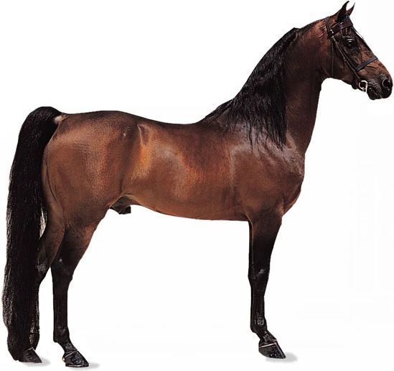
Output(inferences)
Horse.jpg

img_path = "/content/horse.jpg"
img = preprocess_image(img_path)

caption = generate_caption(model, img, vectorizer)
print("Generated caption:", caption)

final output
Generated caption: <start> a brown dog is chewing on a red leash <end>

Comments
1.The model understands language and the generation of text works like a charm
2.The model is not accurate as shown above it predicts an animal but a wrong one to actual result
3.So far so good…I now have somewhere to latch on and

Things to add or change in the next training session
1. Download the whole dataset including test and validation splits to use in model evaluation.
2. Add .repeat() in the training dataset to allow data to be passed again through the model repeatedly
3.Add keras serialization to custom layers for them to be saved with the model
4.Try using GPU in google colab and see the results
5. Process the generated output to remove special tags

2nd training on flickr8k dataset all 5 captions of 8k images(9th September 2025)
->Trained on T4 GPU
Model Training
Epoch 1/10
937/937 ━━━━━━━━━━━━━━━━━━━━ 0s 549ms/step - accuracy: 0.1199 - loss: 4.2664
/usr/local/lib/python3.12/dist-packages/keras/src/trainers/epoch_iterator.py:160: UserWarning: Your input ran out of data; interrupting training. Make sure that your dataset or generator can generate at least `steps_per_epoch * epochs` batches. You may need to use the `.repeat()` function when building your dataset.
self._interrupted_warning()
937/937 ━━━━━━━━━━━━━━━━━━━━ 727s 700ms/step - accuracy: 0.1199 - loss: 4.2657 - val_accuracy: 0.1505 - val_loss: 3.3349
Epoch 2/10
937/937 ━━━━━━━━━━━━━━━━━━━━ 659s 683ms/step - accuracy: 0.1576 - loss: 3.0778 - val_accuracy: 0.1557 - val_loss: 3.2281
Epoch 3/10
937/937 ━━━━━━━━━━━━━━━━━━━━ 646s 690ms/step - accuracy: 0.1685 - loss: 2.7808 - val_accuracy: 0.1565 - val_loss: 3.2111
Epoch 4/10
937/937 ━━━━━━━━━━━━━━━━━━━━ 644s 687ms/step - accuracy: 0.1771 - loss: 2.5788 - val_accuracy: 0.1574 - val_loss: 3.2209
Epoch 5/10
937/937 ━━━━━━━━━━━━━━━━━━━━ 653s 697ms/step - accuracy: 0.1830 - loss: 2.4259 - val_accuracy: 0.1581 - val_loss: 3.2724
Epoch 6/10
937/937 ━━━━━━━━━━━━━━━━━━━━ 655s 700ms/step - accuracy: 0.1896 - loss: 2.3039 - val_accuracy: 0.1558 - val_loss: 3.3070
Epoch 7/10
937/937 ━━━━━━━━━━━━━━━━━━━━ 689s 736ms/step - accuracy: 0.1951 - loss: 2.1974 - val_accuracy: 0.1565 - val_loss: 3.3538
Epoch 8/10
937/937 ━━━━━━━━━━━━━━━━━━━━ 643s 687ms/step - accuracy: 0.2000 - loss: 2.1101 - val_accuracy: 0.1541 - val_loss: 3.3763
Epoch 9/10
937/937 ━━━━━━━━━━━━━━━━━━━━ 660s 705ms/step - accuracy: 0.2060 - loss: 2.0296 - val_accuracy: 0.1549 - val_loss: 3.4328
Epoch 10/10
937/937 ━━━━━━━━━━━━━━━━━━━━ 641s 684ms/step - accuracy: 0.2099 - loss: 1.9617 - val_accuracy: 0.1530 - val_loss: 3.4775

Total Training time=1hr 50 minutes

Output(inferences)
Horse.jpg

img_path = "/content/horse.jpg"
img = preprocess_image(img_path)

caption = generate_caption(model, img, vectorizer)

if "<start>" in caption:
caption = caption.split("<start>")[1]
if "<end>" in caption:
caption = caption.split("<end>")[0]

print("Generated caption:", caption)

final output
Generated caption: a brown and white dog is running through a grassy area

Comments
1.The model understands language and the generation of text just like its predecessor
2.The model is not accurate as shown above it predicts an animal but a wrong one to actual result
3.Something strange came up during this training …
I am working also on creating models using pretarained models and The outputs gave something quite similar.
PRETRAINED MODEL(DEKAI 0)
CODE:
from transformers import VisionEncoderDecoderModel, ViTFeatureExtractor, AutoTokenizer
import tensorflow as tf
from PIL import Image

# Load pretrained model (TensorFlow)
model = VisionEncoderDecoderModel.from_pretrained("nlpconnect/vit-gpt2-image-captioning")
feature_extractor = ViTFeatureExtractor.from_pretrained("nlpconnect/vit-gpt2-image-captioning")
tokenizer = AutoTokenizer.from_pretrained("nlpconnect/vit-gpt2-image-captioning")

# Load and preprocess an image
image = Image.open("/content/horse.webp")
pixel_values = feature_extractor(images=image, return_tensors="pt").pixel_values # <--- 'tf'

# Generate caption
output_ids = model.generate(pixel_values, max_length=16, num_beams=4)
caption = tokenizer.decode(output_ids[0].numpy(), skip_special_tokens=True)

print("Generated caption:", caption)

Output:
The attention mask is not set and cannot be inferred from input because pad token is same as eos token. As a consequence, you may observe unexpected behavior. Please pass your input's `attention_mask` to obtain reliable results.
We strongly recommend passing in an `attention_mask` since your input_ids may be padded. See https://huggingface.co/docs/transformers/troubleshooting#incorrect-output-when-padding-tokens-arent-masked.
You may ignore this warning if your `pad_token_id` (50256) is identical to the `bos_token_id` (50256), `eos_token_id` (50256), or the `sep_token_id` (None), and your input is not padded.
Generated caption: a brown horse standing on top of a dry grass covered field

In the image it also strangely predicts a grassy field….maybe the image has a lot more to show.

Things to add or change in the next training session
1. Place repeat() at the right place before batching
2. Change saving checkpoints from weights only to .keras models
3.Change def call(self)

Finetuning DekaImg0
->Changed from viTcaptioning model to viTclassification model because the finetuning dataset is made up of 84 distinct labels for 100 images that have been augmented to 700 images .

Finetuning logs
Epoch | Training Loss | Validation Loss | Accuracy
1 | 4.119800 | 3.926720 | 0.170886
2 | 3.606100 | 3.511261 | 0.284810
3 | 3.213300 | 3.187216 | 0.335443
4 | 2.816000 | 2.924625 | 0.424051
5 | 2.526500 | 2.706318 | 0.481013
6 | 2.367900 | 2.514149 | 0.550633
7 | 2.038600 | 2.339683 | 0.607595
8 | 1.858100 | 2.187205 | 0.645570
9 | 1.633100 | 2.061160 | 0.670886
10 | 1.477500 | 1.955630 | 0.683544
11 | 1.444800 | 1.868931 | 0.727848
12 | 1.327200 | 1.803766 | 0.734177
13 | 1.211600 | 1.756869 | 0.746835
14 | 1.231000 | 1.728712 | 0.759494
15 | 1.229900 | 1.719108 | 0.759494

TrainOutput(global_step=1200, training_loss=2.19866891225179, metrics={'train_runtime': 752.8264, 'train_samples_per_second': 12.632, 'train_steps_per_second': 1.594, 'total_flos': 7.374904344480154e+17, 'train_loss': 2.19866891225179, 'epoch': 15.0})
Inference
test_image = "/kaggle/input/dedan-img-dataset/IMG_6174.jpg"
print(f"Predicted Landmark: {predict_landmark(test_image)}")

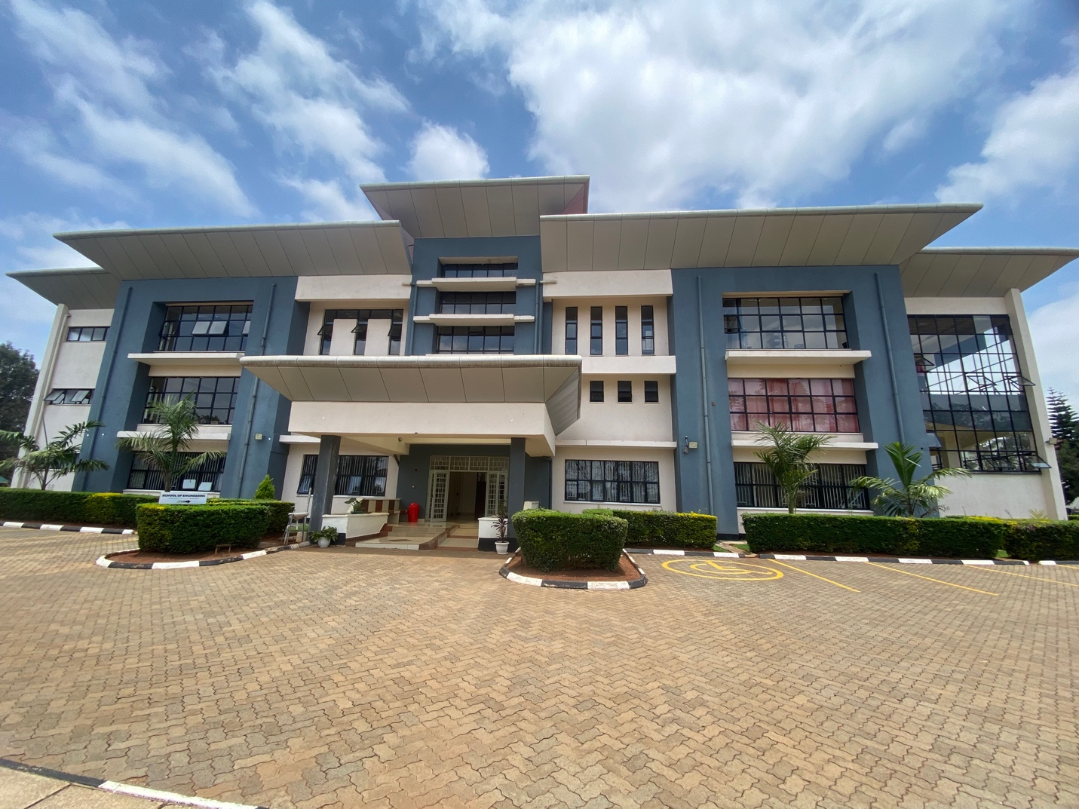
Predicted Landmark: Anterior side of School of engineering

References
[1] Ali soofastaei . , “Virtual Assistant” pp 1 2021
[2] Wadawadagi, Ramesh & Pagi, Veerappa. (2020). Sentiment analysis with deep neural networks: comparative study and performance assessment. Artificial Intelligence Review. 53. 10.1007/s10462-020-09845-2.
[3] D Christopher books , EDUCAUSE Quick Poll results Edition:Artificial Intelligence in higher education
[4] Machine Learning Text classification model with NLP approach” Maria Razno N Technical University Kharkiv,Ukraine
[5] Wikipedia - Russell & Norvig (2021), pp. 1–4.
[6] Dana H. Ballard; Christopher M. Brown (1982). Computer Vision. Prentice Hall.
[7] Google AI Overview
[8] OpenAI. (2023). GPT-4o model [Large language model].
[9] Devlin, J., Chang, M. W., Lee, K., & Toutanova, K. (2019).
BERT: Pre-training of deep bidirectional transformers for language understanding.
[10] LeCun, Y., Bottou, L., Bengio, Y., & Haffner, P. (1998).
Gradient-based learning applied to document recognition
[11] Krizhevsky, A., Sutskever, I., & Hinton, G. E. (2012).
ImageNet classification with deep convolutional neural networks.
[12] Dosovitskiy, A., Beyer, L., Kolesnikov, A., Weissenborn, D., Zhai, X., Unterthiner, T., ... & Houlsby, N. (2021).
An image is worth 16x16 words: Transformers for image recognition at scale.
[13] Nagadivya Balasurbramaniam , Marjo Kauppinen ,Sari Kujala (2020)
Ethical guidelines for solving ethical issues and developing AI systems

